Spend Management System

SMS – Spend Management System enables the Financial Analyst to create vendors and track projected spending by month and get projections for Quarter and year.

Step 1
Install MySQL server and Create DataBase - SMSDB and table - Vendor.

create table IF NOT EXISTS SMSDB.Vendor ( id VARCHAR(20) PRIMARY KEY, name VARCHAR(20) not null, poCreated BOOLEAN, poNumber BIGINT(20), poDetails VARCHAR(20), poType VARCHAR(20) );

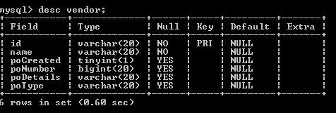

Step 2
Run mvn clean and mvn package on the project. Deploy the war file in Tomcat server.

Step 3
Create a new Vendor

Open the url http://localhost:8080/SMS/vendor/new.form

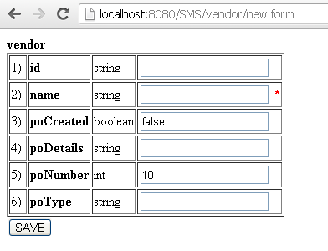

Fill in the details and click on save as shown below.

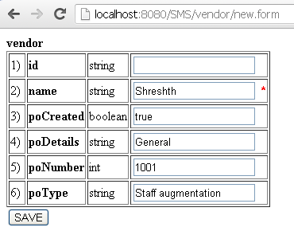

This would create a Vendor record in database as shown below.

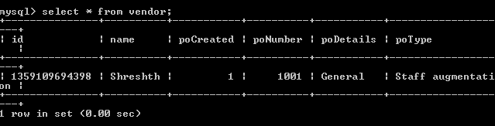

Similarly more Vendors can be created.

Step 4
Retrieve all Vendor records

Open the url http://localhost:8080/SMS/vendor

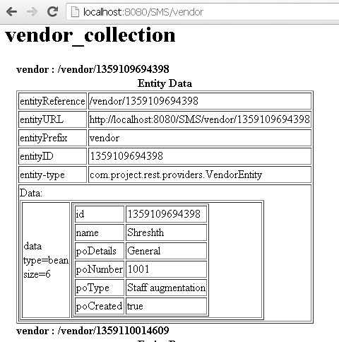

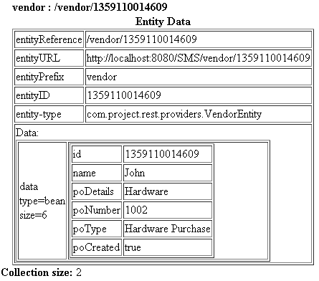

Step 5
Retrieve a specific Vendor record

Open the url http://localhost:8080/SMS/vendor/1359109694398

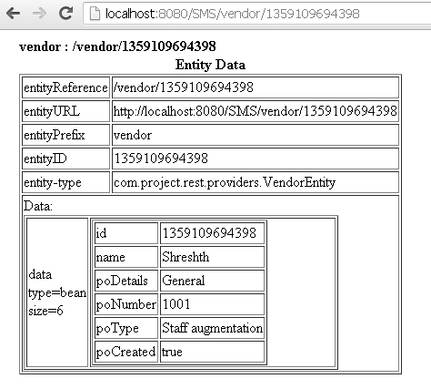

Step 6
Edit Vendor

Open the url http://localhost:8080/SMS/vendor/1359109694398/edit.form

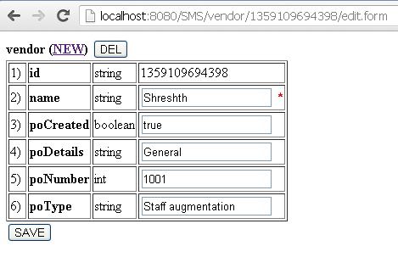

Make the needed changes and click on Save.

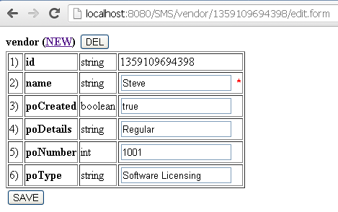

This would modify that Vendor record in database as shown below.

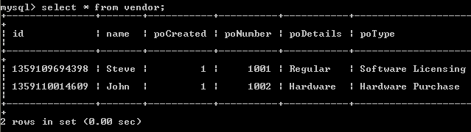

Step 7
Delete Vendor

Open the url http://localhost:8080/SMS/vendor/1359109694398/delete.form

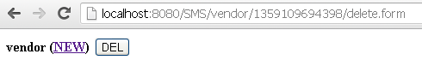

Click on Delete

This would delete the Vendor record in database as shown below.

